

UNIVERSITY OF BUEA
FACULTY OF ENGINEERING AND TECHNOLOGY
DEPARTMENT OF COMPUTER ENGINEERIN
INTERNET PROGRAMMING AND MOBILE PROGRAMMING
CEF440
Task 2: Requirement Gathering

GROUP 9

NAME | MATRICULE
FONTEBO TCHICKNWIGHE ACHAH | FE23A062
ANU ROLENCE AKEM | FE23A013
NEIL AMBAYI MPOCHE | FE23A105
OTANG JANICE OTANG | FE23A134
ASHU ALBERIC BESSONG | FE23A015

REQUIREMENT GATHERING REPORT

Adaptive E-Learning Platform Based on Quality of Experience (QoE)
- INTRODUCTION
The rapid advancement of digital technologies has significantly transformed the education sector, leading to the widespread adoption of e-learning platforms as essential tools for teaching and learning. These platforms facilitate access to educational resources, enable virtual classroom participation, and support the exchange of learning materials irrespective of geographical location.
However, the effectiveness of e-learning systems is highly dependent on stable internet connectivity, adequate bandwidth, and access to appropriate digital devices. In low-resource environments such as Cameroon and other parts of Sub-Saharan Africa, users frequently experience challenges including unstable network connectivity, high data costs, limited bandwidth, and the use of low-end devices. These constraints often result in degraded learning experiences characterized by video buffering, audio latency, session interruptions, and limited access to learning content.
To address these challenges, this project focuses on the design of an adaptive e-learning platform based on Quality of Experience (QoE). The proposed system dynamically adjusts content delivery modes such as video, audio, and text based on real-time network conditions. This adaptive mechanism aims to ensure continuity of learning even under constrained network environments.
The requirement gathering phase is a critical stage in system development, as it enables the identification of user needs, system expectations, and contextual challenges faced by stakeholders. This report presents the outcome of stakeholder analysis, requirement elicitation techniques, data collection processes, data preprocessing activities, and user reluctance assessment conducted to inform the system design.
- STAKEHOLDER IDENTIFICATION
Stakeholders refer to individuals, groups, or organizations that are either directly involved in, affected by, or have an interest in the development and use of the system.

2.1 Primary Stakeholders
Primary stakeholders are direct users of the system and are actively involved in its operation:
- Students (end-users of the e-learning platform)
- Lecturers / Instructors (content creators and facilitators)

2.2 Secondary Stakeholders
Secondary stakeholders provide support services or governance functions:
- University Administration (policy formulation and institutional approval)
- IT Support Staff (system maintenance and technical support)

2.3 External Stakeholders
External stakeholders influence system usage indirectly:
- Parents / Guardians (financial and device support for learners)
- Internet Service Providers (network infrastructure and service quality)

3. REQUIREMENT GATHERING TECHNIQUES
Requirement gathering techniques are structured methods used to collect relevant information from stakeholders in order to define system requirements accurately.
The following techniques were employed in this study:

3.1 Online Survey (Google Forms)
A structured questionnaire was developed using Google Forms and distributed to students and lecturers. This method enabled the collection of quantitative and qualitative data regarding user experiences, preferences, and challenges in e-learning environments.
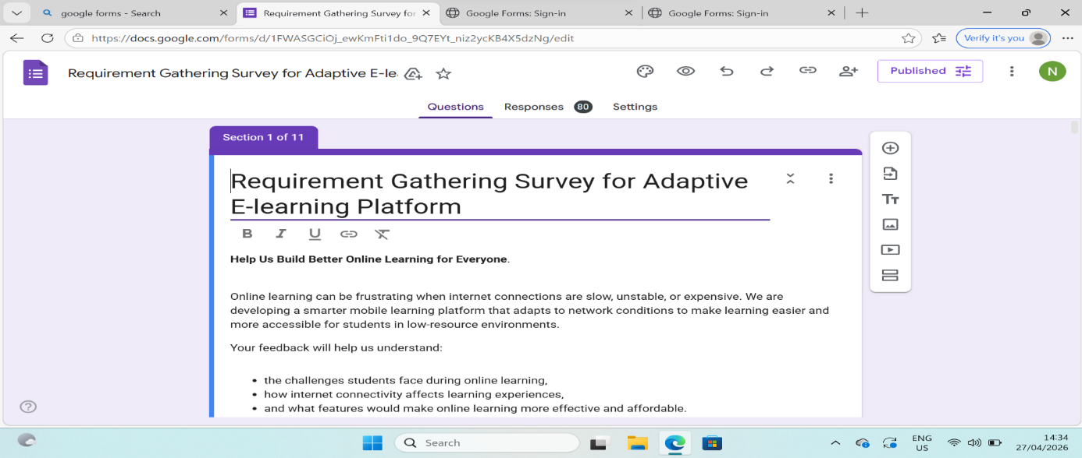

3.2 Interviews
Informal interviews were conducted with lecturers to understand teaching challenges.

3.3 Observation
Existing platforms like Zoom and Moodle were observed to identify limitations in low-bandwidth environments.

3.4 Brainstorming
Group discussions were held to define adaptive system features such as video quality switching and audio fallback mode.

4. DATA GATHERING
Data gathering refers to the systematic process of collecting raw information from stakeholders in order to understand existing problems and support system design decisions.
Data was primarily collected through a Google Forms survey distributed to students and lecturers.

4.1 Collected Data Categories
The survey focused on the following key areas:
- User role classification (student or lecturer)
- Internet reliability during learning sessions
- Preferred content format under poor connectivity conditions
- Features expected to improve learning experience
- Level of satisfaction with existing e-learning platforms
- Perception of challenges faced in low-resource environments
- Device types used for accessing learning platforms
- Learning preferences and behavioral patterns
- Open-ended suggestions for system improvement

4.2 Data Overview
The collected dataset includes responses from participants across different academic levels and device categories. The data provides insight into connectivity limitations, user preferences, and perceived barriers to effective e-learning adoption.

Collected Data Includes:
- Which best describes you?
- How reliable is your internet connection during online learning sessions?
- During poor connectivity, what content format do you prefer?
- Which feature would improve you learning experience the most?\
- What additional suggestions would improve online learning in low-resource environments?
- How satisfied are you with existing e-learning platforms?
- Do you think students in low-resource environments struggle with existing e-learning platforms?
- Internet quality of users
- Device types
- Learning preferences
- Challenges faced in online learning
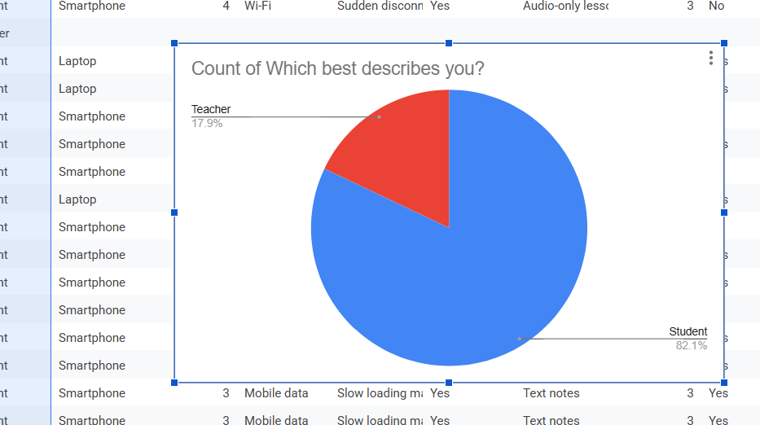
Number of participants
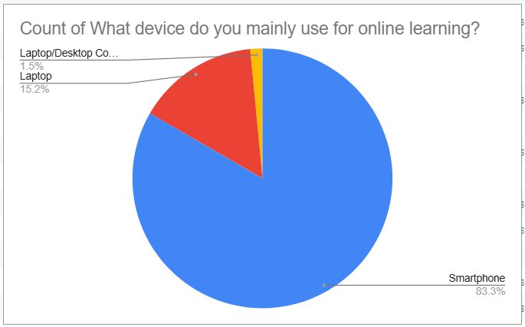
Device types

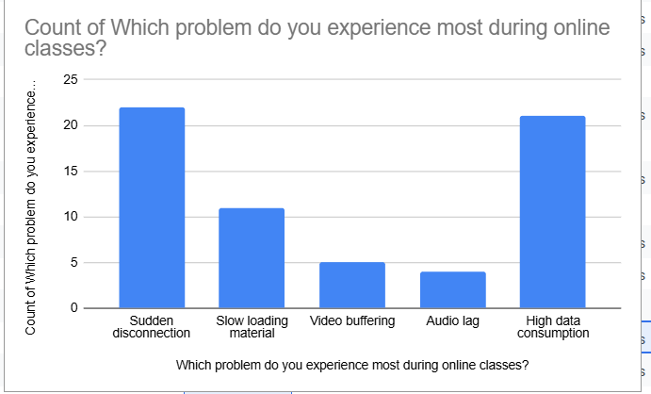

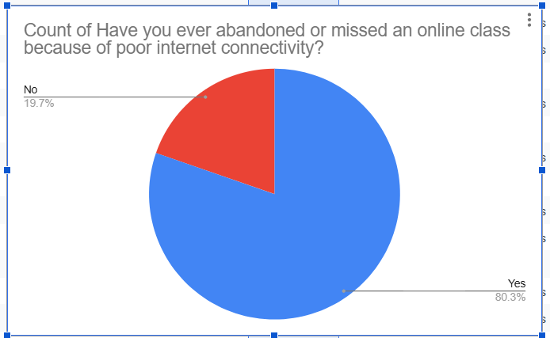

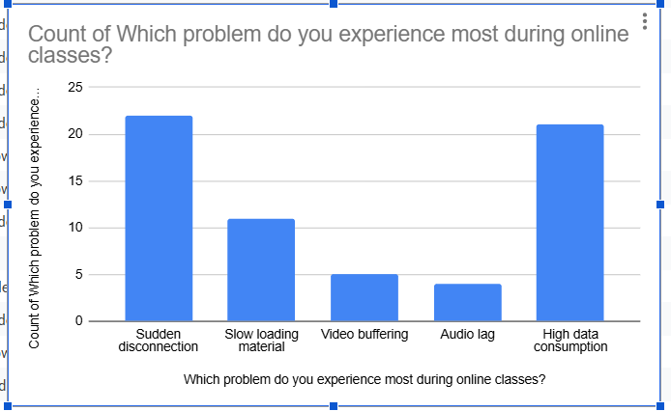
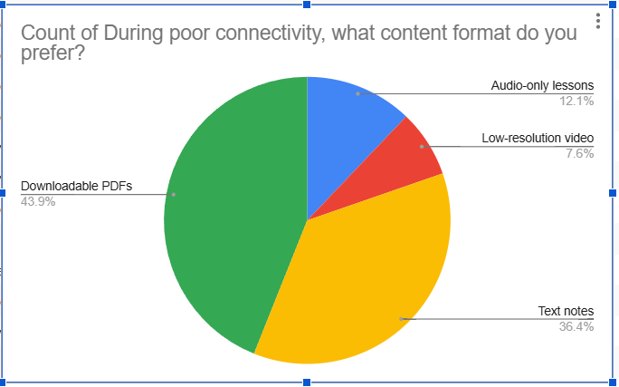

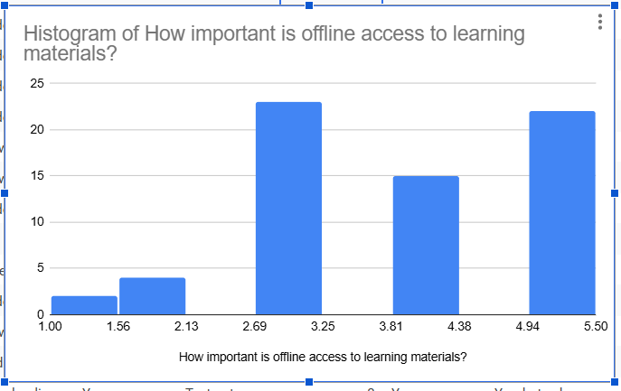
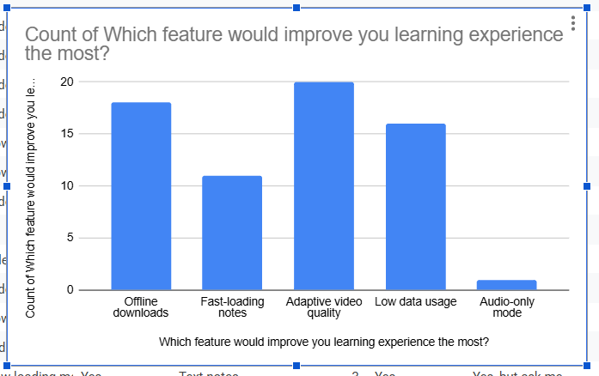

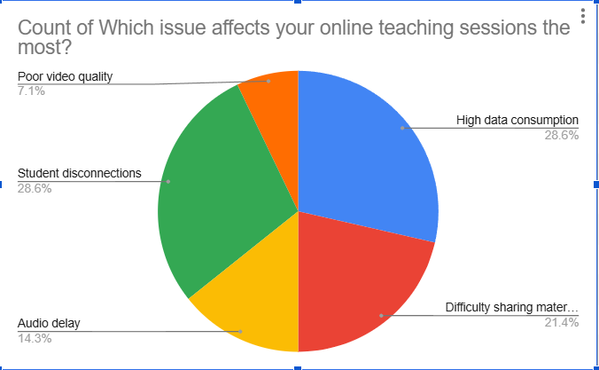

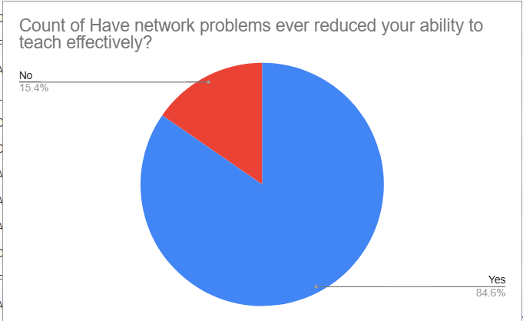
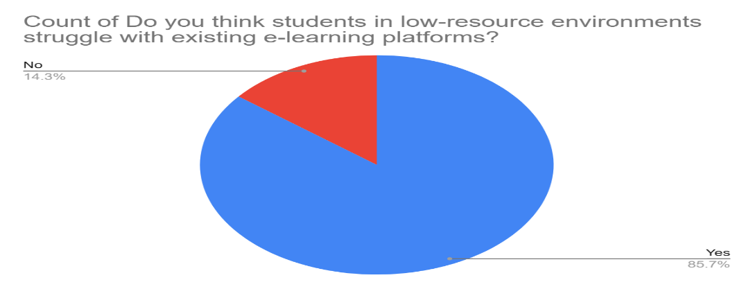
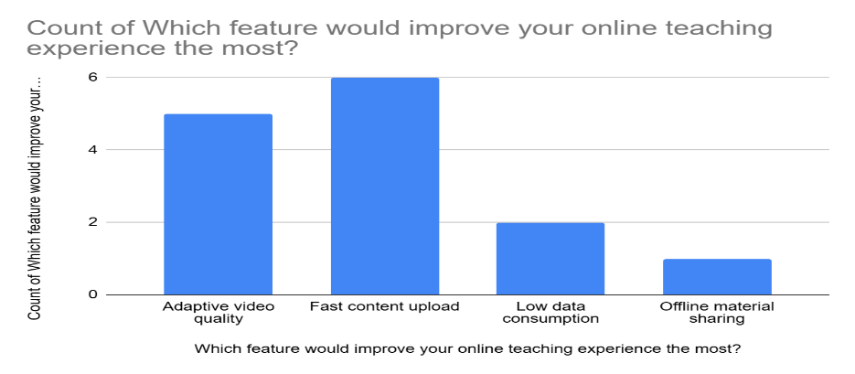
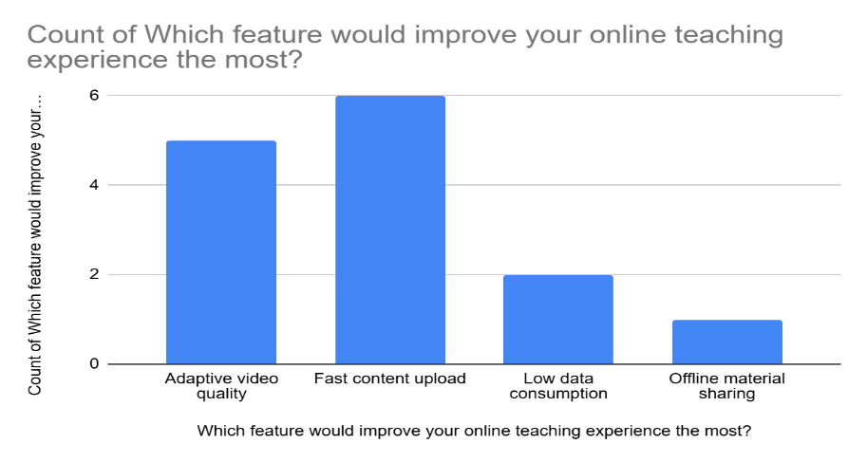

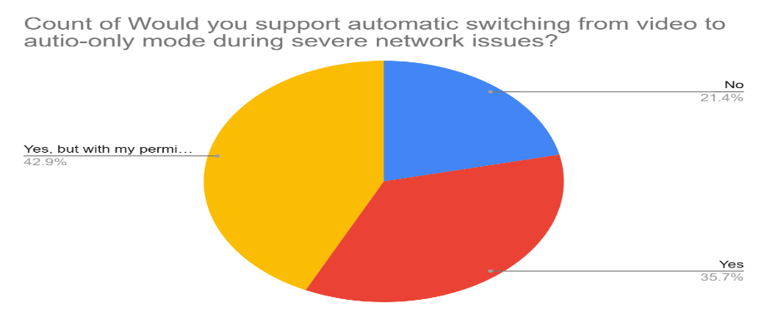
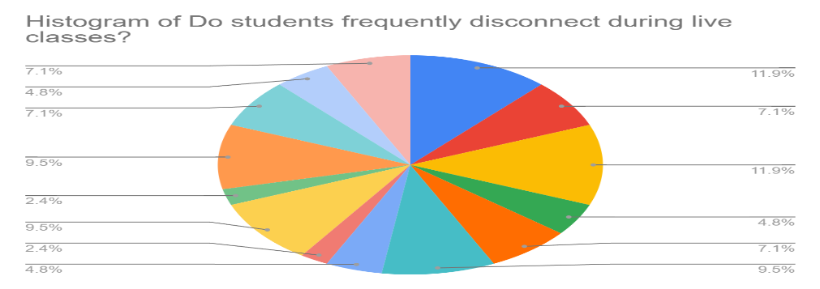

5. DATA CLEANING
Data cleaning is the process of identifying and correcting inaccuracies, inconsistencies, and incomplete entries within a dataset to ensure its reliability for analysis.
The following preprocessing activities were performed:
- Removal of incomplete or partially filled responses to ensure data integrity
- Trimming of leading and trailing whitespace characters to standardize text entries
- Identification and elimination of duplicate records to avoid redundancy
- Detection of missing values and replacement with standardized null indicators (NA) where appropriate
- Adjustment of dataset structure for improved readability and analysis efficiency

5.1 Outcome of Data Cleaning
The cleaning process resulted in a refined dataset with improved consistency and reduced noise, thereby enhancing the reliability of subsequent analysis.
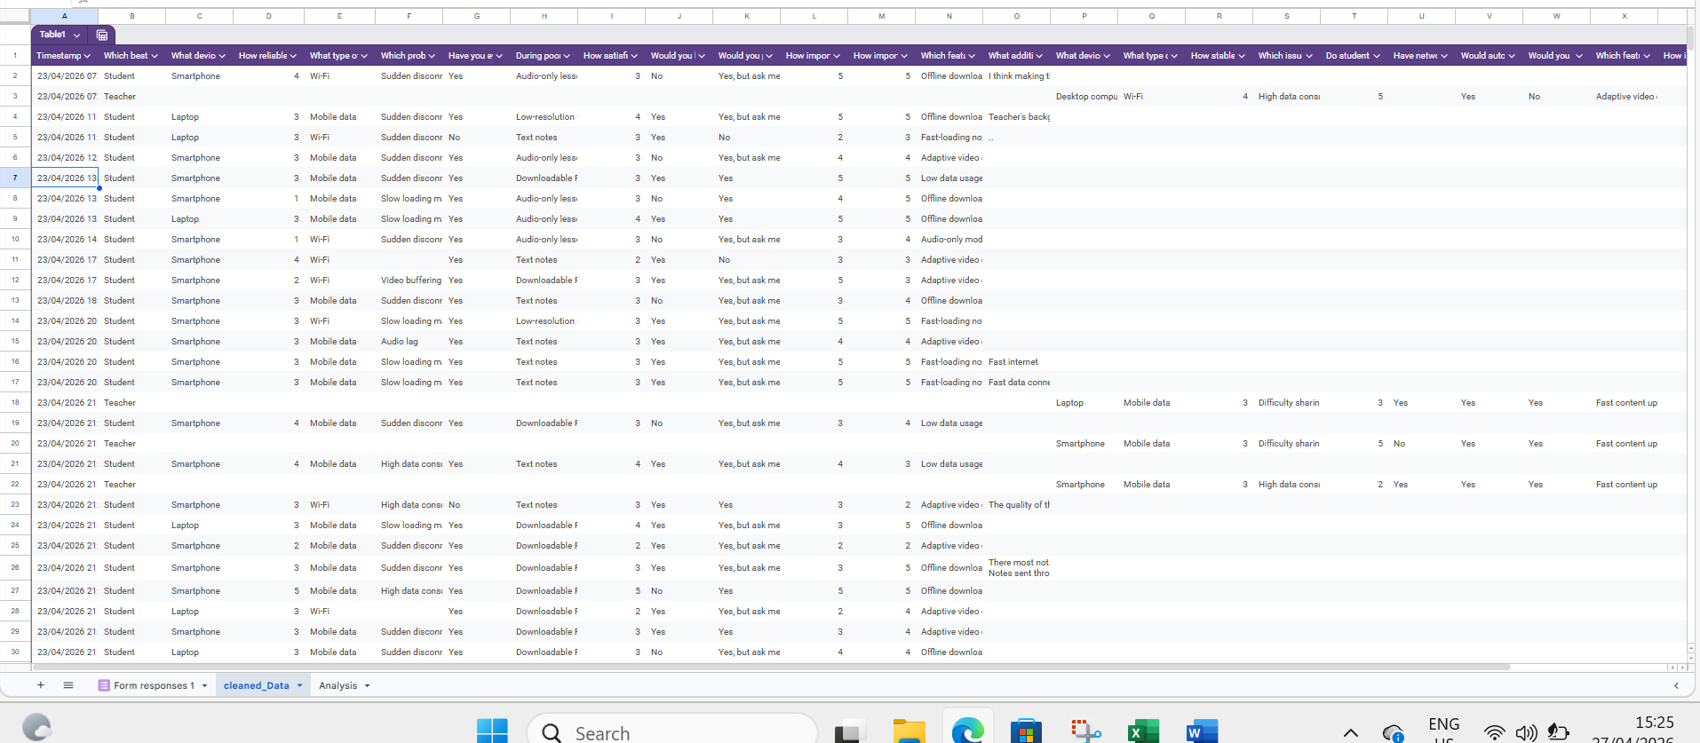
Raw data 1 extracted from the google sheet
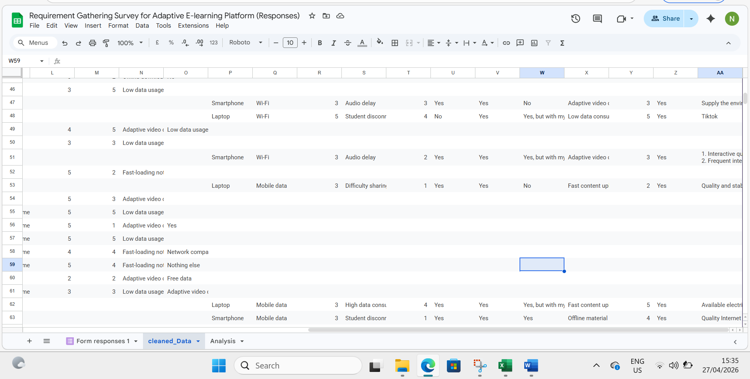
Raw data 2
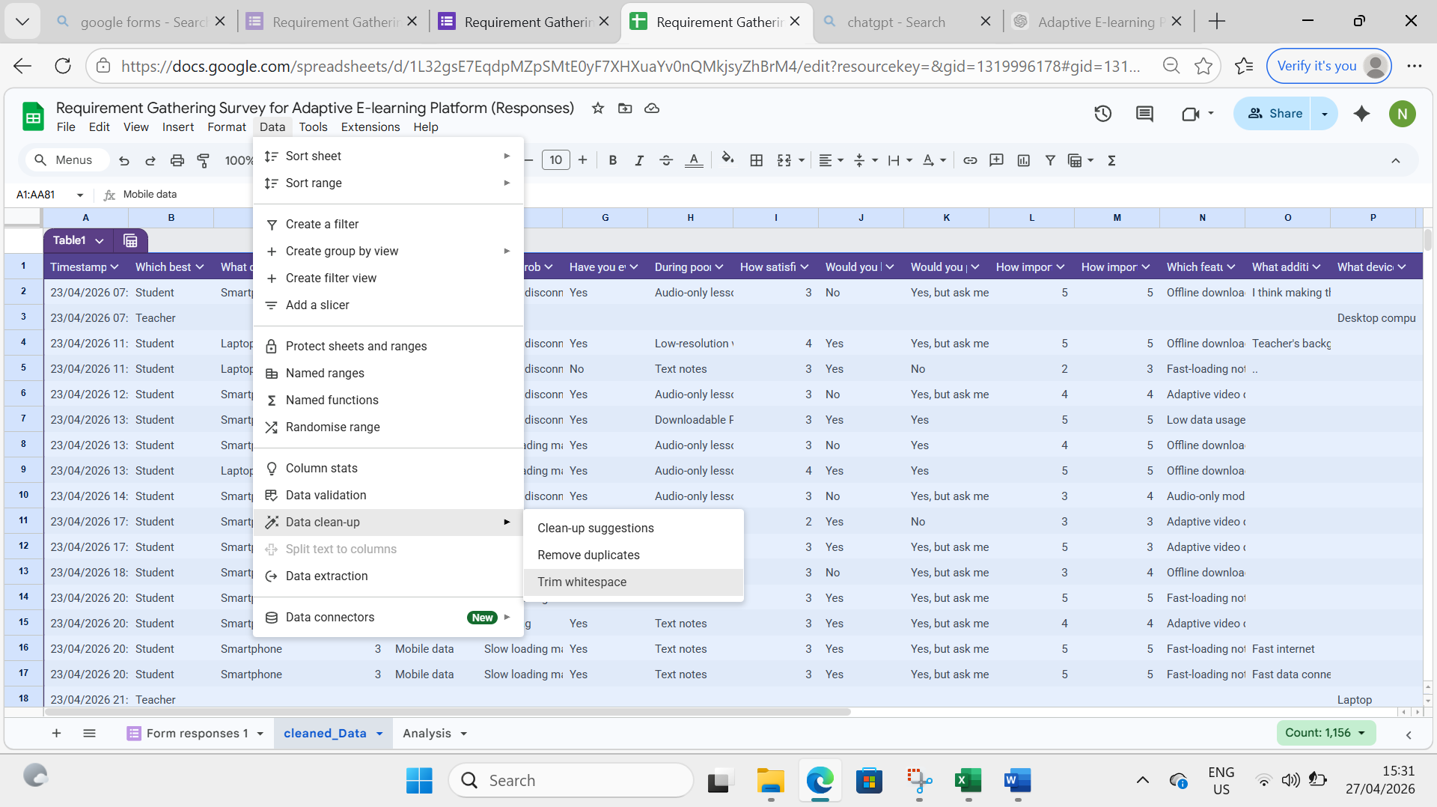
Trim whitespace which helps to remove extra spaces.
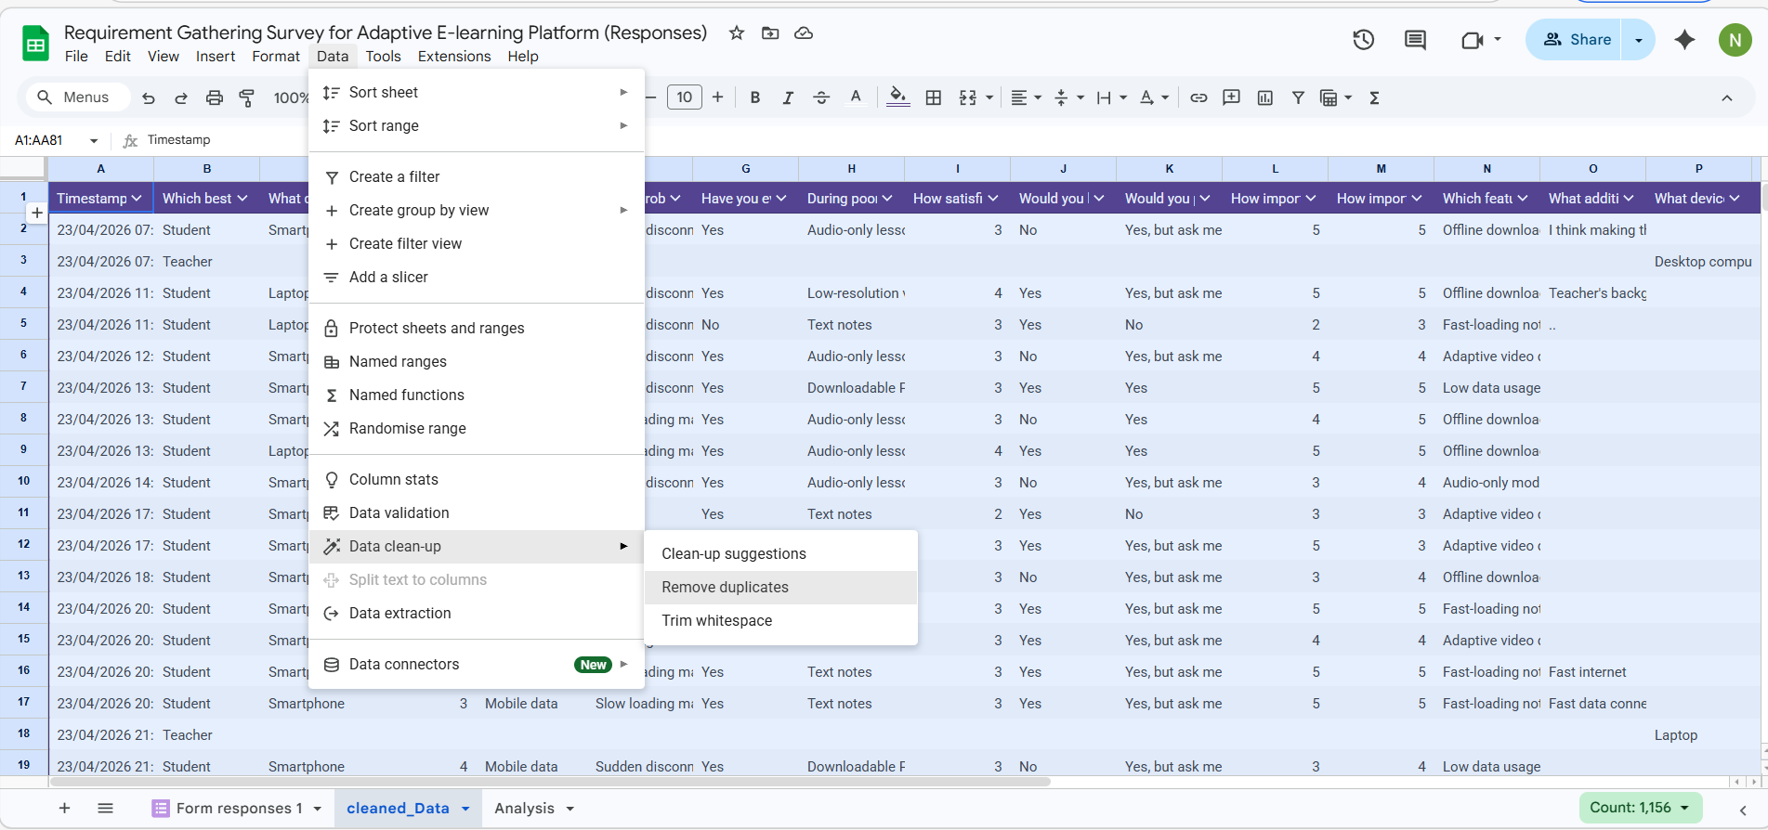It helps to remove duplicates.
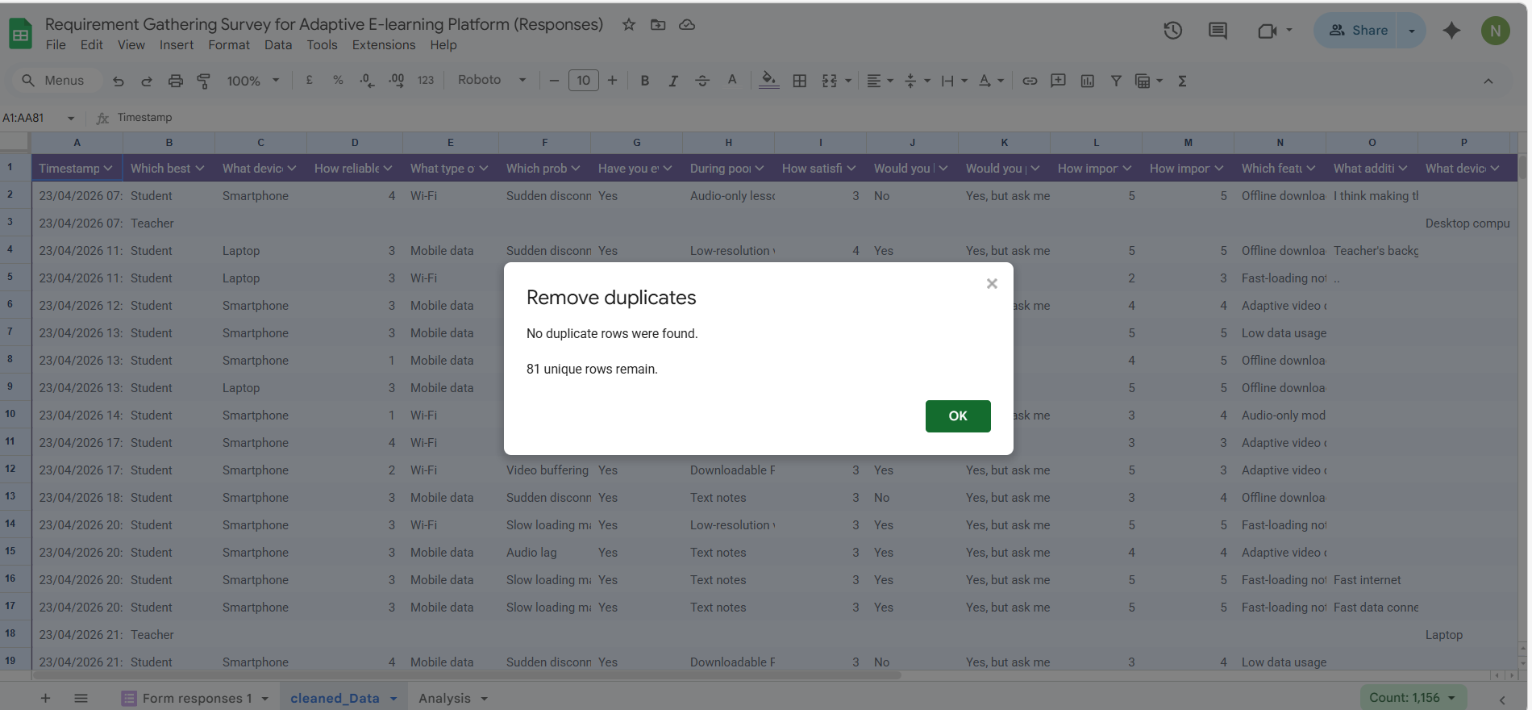
No duplicates found.
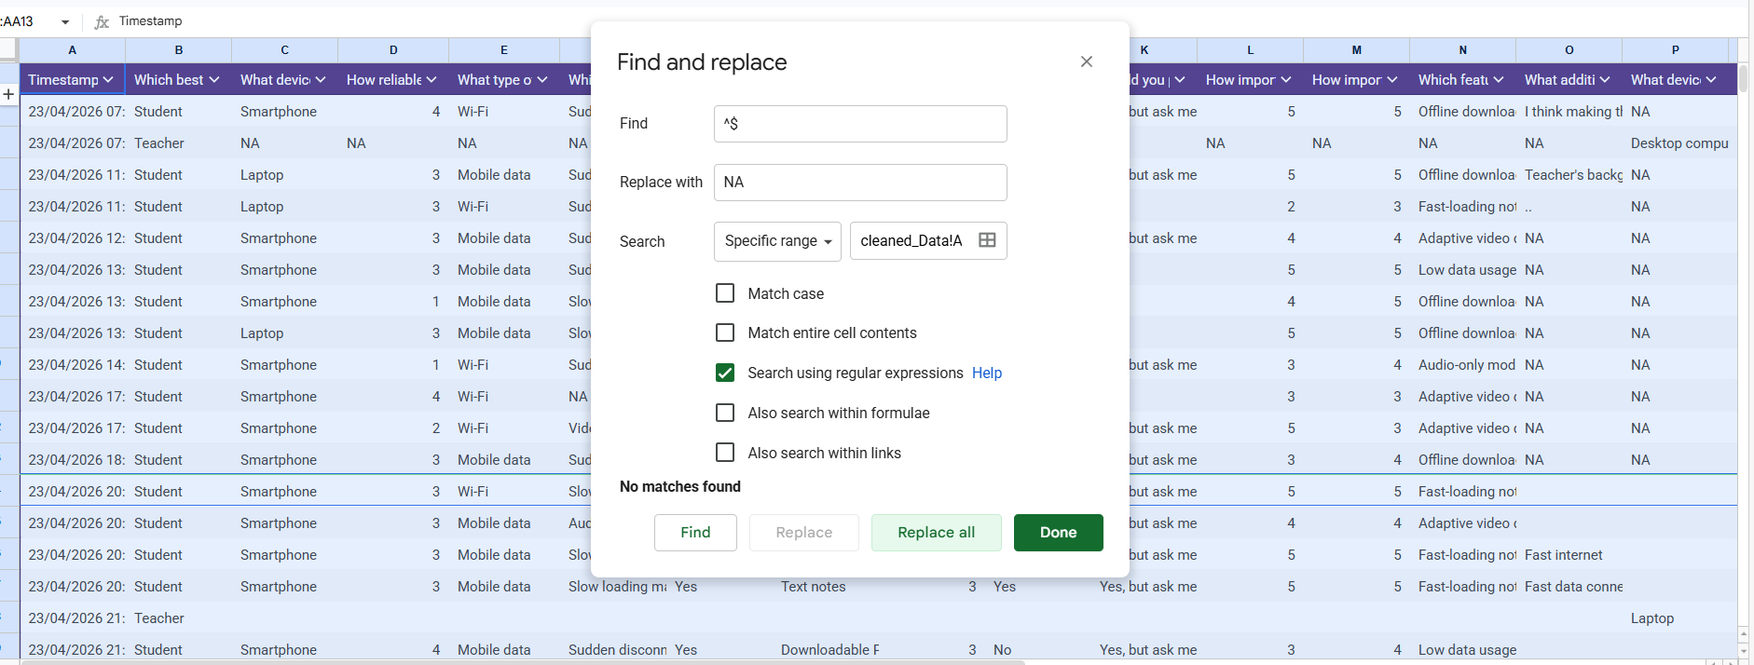
Finding empty spaces to replace them with NA
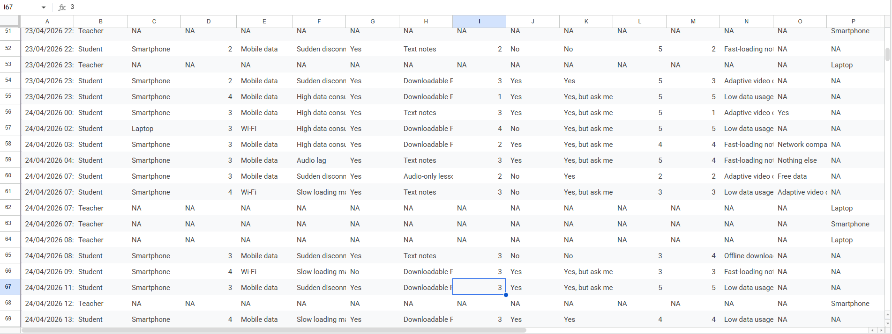
Output after replacing empty spaces with NA
6. USER RELUCTANCE ASSESSMENT
User reluctance refers to the behavioral and contextual factors that hinder the adoption and consistent use of a system.
The analysis revealed the following key barriers:
- High data costs significantly limit continuous access to e-learning platforms
- Poor and unstable network connectivity discourages active participation in online learning activities
- A segment of users exhibits a preference for traditional classroom-based learning methods
- Limitations in device capabilities restrict access to multimedia-rich content
These findings indicate that both infrastructural and behavioral factors influence the adoption of e-learning systems in low-resource environments.




7. SUMMARY OF FINDINGS
The requirement gathering process revealed several critical insights relevant to system design:
- Network instability is the most significant barrier affecting e-learning effectiveness
- Users demonstrate a strong preference for low-data and lightweight learning solutions
- There is a clear need for adaptive content delivery mechanisms capable of adjusting to network conditions
- Offline accessibility features are highly demanded by a significant proportion of users
These findings provide a foundational basis for the design of an adaptive e-learning system tailored to low-resource environments.

